DEPARTMENT OF INFORMATION TECHNOLOGY

A

PROJECT REPORT

ON

“PAYROLL MANAGEMENT SYSTEM”

BY

Shubham Chaudhari Roll No. :-10

Arpita Dhote Roll No. :-15

Mrunali Gorde Roll No. :- 22

Durvesh Palkar Roll No. :- 48

CLASS: TE IT

YEAR: 2019-2020

DEPARTMENT OF INFORMATION TECHNOLOGY

CERTIFICATE

This is to certify that

Shubham Chaudhari

Arpita Dhote

Mrunali Gorde

Durvesh Palkar

have successfully completed

PROJECT REPORT ON

“PAYROLL MANAGEMENT SYSTEM”

In partial fulfillment of third year first semester degree course in Information Technology in the academic Year 2019-2020

Date: - 14 October 2019

Dr. P.A. Patil Dr. Meenakshi Thalor

(Project Guide) (H.O.D)

Dept. of Information Technology Dept. of Information Technology

AISSMS IOIT Pune AISSMS IOIT Pune

**INDEX**

1. **Abstract -------------------------------------------------------4**
2. **Introduction ------------------------------------------------5-6**
3. **Project Scope ----------------------------------------------7-8**
4. **Requirement Analysis -------------------------------------9**
5. **Feasible Study-------------------------------------------10-11**
6. **Technology used----------------------------------------12-13**
7. **Primary Goal -----------------------------------------------14**
8. **ER Diagram -------------------------------------------------15**
9. **Screenshot of Front end ------------------------------16-21**

**10. Future Enchancement--------------------------------22-24**

**11. Benefits--------------------------------------------------25-26**

**12. Conclusion ------------------------------------------------27**

**13. Reference --------------------------------------------------28**

**ABSTRACT**

The purpose of Payroll Management System is to automate the existing manual system by the help of computerized equipments and full-fledged computer software, fulfilling their requirements, so that their valuable data/information can be stored for a longer period with easy accessing and manipulation of the same. The required software and hardware are easily available and easy to work with.

Payroll Management System, as described above, can lead to error free, secure reliable and fast management system. It can assist the user to concentrate on their other activities rather to concentrate on the record keeping. Thus it will help organization in better utilization of resources. The organization can maintain computerized records without redundant entries. That means that one need not be distracted by information that is not relevant, while being able to reach the information.

The aim is to automate its existing manual system by the help of computerized equipments and full-fledged computer software, fulfilling their requirements, so that their valuable data information can be stored for a longer period with easy accessing and manipulation of the same. Basically the project describes how to manage for good performance and better services for the clients.

**INTRODUCTION OF PAYROLL MANAGEMENT SYSTEM**

The "Payroll Management System" has been developed to override the problems prevailing in the practicing manual system. This software is supported to eliminate and in some cases reduce the hardships faced by this existing system. Moreover this system is designed for the particular need of the company to carry out operations in a smooth and effective manner. The application is reduced as much as possible to avoid errors while entering the data. It also provides error message while entering invalid data. No formal knowledge is needed for the user to use this system. Thus by this all it proves it is user-friendly. Payroll Management System as described above, can lead to error free, secure reliable and fast management system. It can assist the user to concentrate on their other activities rather to concentrate on the record keeping. Thus it will help organization in better utilization of resources. Every organization, whether big or small. has challenges to overcome and managing the information of Employee Salary, Employee Department, Payroll, Payslip. Every Payroll Management System has different Employee needs, therefore we design exclusive employee management systems that are adapted to your managerial requirements. This is designed to assist in strategic planning, and will help you ensure that your organization is equipped with the right level of information and details for your future goals. Also, for those busy executive who are always on the go, our systems come with remote access features, which will allow you to manage your workforce anytime, at all times. These systems will ultimately allow you to better manage resources.

**PROJECT SCOPE**

It may help collecting perfect management in details. In a very short time, the collection will be obvious, simple and sensible. It will help a person to know the management of passed year perfectly and vividly. It also helps in current all works relative to Payroll Management System. It will be also reduced the cost of collecting the management & collection procedure will go on smoothly.

Our project aims at Business process automation, ie. we have tried to Business computerize various processes of Payroll Management System.

* In computer system the person has to fill the various forms & number of copies of the forms can be easily generated at a time.
* In computer system, it is not necessary to create the manifest but we can directly print it, which saves our time.
* To assist the staff in capturing the effort spent on their respective working areas
* To utilize resources in an efficient manner by increasing their productivity through automation
* The system generates types of information that can be used for various purposes.
* It satisfy the user requirement
* Be easy to understand by the user and operator
* Be easy to operate
* Have a good user interface
* Be expandable
* Delivered on schedule within the budget.

**REQUIREMENT ANALYSIS**

* PLATFORM :-

Windows Operating system

* SOFTWARE REQUIREMENT :-

Microsoft windows

* HARDWARE SPECIFICATIONS :-

Processor: - Intel Pentium O Mere

Motherboard: - Intel Chipset Motherboard

Ram: - 128 MB or more

Cache: - 512 KB

Hard disk -16 GB hard disk recommended

Monitor: - 1024 x 720 Display

Disk Drive: - 1.44MB Floppy Disk Drive

**FEASIBLE STUDY**

After doing the project Employee Payroll System, study and analyzing all the existing or required functionalities of the system, the next task is to do the feasibility study for the project. All projects are feasible given unlimited resources and infinite time.

Feasibility study includes consideration of all the possible ways to provide a solution to the given problem. The proposed solution should satisfy all the user requirements and should be flexible enough so that future changes can be easily done based on the future upcoming requirements.

A. Economical Feasibility :-

This is a very important aspect to be considered while developing a project. We decided the technology based on minimum possible cost factor.

* All hardware and software cost has to be borne by the organization.
* Overall we have estimated that the benefits the organization is going to receive from the proposed system will surely overcome the initial costs and the later on running cost for system.

B. Technical Feasibility :-

This included the study of function, performance and constraints that may affect the ability to achieve an acceptable system. For this feasibility study, we studied complete functionality to be provided in the system, as described in the System Requirement Specification (SRS), and checked if everything was possible using different type of frontend and backend platform.

C. Operational Feasibility :-

No doubt the proposed system is fully GUI based that is very user friendly and all inputs to be taken all self-explanatory even to a layman. Besides, a proper training has been conducted to let know the essence of the system to the users so that the comfortable with new system. As far our study is concerned the clients are comfortable and happy as the system has cut down their loads and doing.

**TECHNOLOGY USED**

1. XAMPP:

**XAMPP** is a free and open-source cross-platform web server solution stack package developed by Apache Friends, consisting mainly of the Apache HTTP Server, MariaDB database, and interpreters for scripts written in the PHP and Perl programming languages. Since most actual web server deployments use the same components as XAMPP, it makes transitioning from a local test server to a live server possible.

1. ATOM:

**Atom** is a free and open-source text and source code editor for macOS, Linux, and Microsoft Windows with support for plug-ins written in Node.js, and embedded Git Control, developed by GitHub. Atom is a desktop application built using web technologies. Most of the extending packages have free software licenses and are community-built and maintained. Atom is based on Electron (formerly known as Atom Shell), a framework that enables cross-platform desktop applications using Chromium and Node.js. It is written in CoffeeScript and Less.

1. HTML5

**HTML5** is a [software solution stack](https://en.wikipedia.org/wiki/Solution_stack) that defines the properties and behaviors of [web page](https://en.wikipedia.org/wiki/Web_page) [content](https://en.wikipedia.org/wiki/Web_content) by implementing a [markup](https://en.wikipedia.org/wiki/Markup_language" \o "Markup language) based [pattern](https://en.wikipedia.org/wiki/Software_design_pattern) to it. HTML5 includes detailed processing models to encourage more interoperable implementations; it extends, improves and rationalizes the markup available for documents, and introduces markup and [application programming interfaces](https://en.wikipedia.org/wiki/Application_programming_interface) (APIs) for complex [web applications](https://en.wikipedia.org/wiki/Web_application).[[6]](https://en.wikipedia.org/wiki/HTML5#cite_note-HTML5diffHTML4-6) For the same reasons, HTML5 is also [a candidate for cross-platform mobile applications](https://en.wikipedia.org/wiki/HTML5_in_mobile_devices), because it includes features designed with low-powered devices in mind.

**PRIMARY GOAL**

The aim of this system is to develop a system which provides proper security and reduces the manual work.

* Security of data.
* Ensure data accuracy.
* Proper control of the higher officials.
* Minimize manual data entry.
* Minimum time needed for the various processing.
* Greater efficiency.
* Better service.
* User friendliness and interactive.
* Minimum time required.

ER DIAGRAM

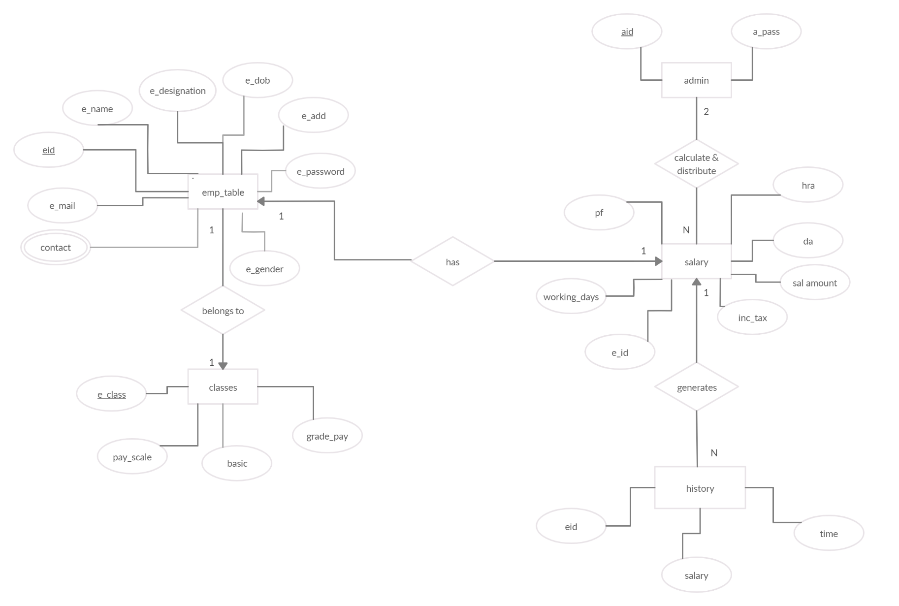

**MODULES**

**EMPLOYEE MODULE:**

Each employee, after login has the following functionalities:

Change password:

When an admin adds a new employee into the database, he/she is given a default password. Therefore, for security purposes each employee can change their password using this feature.

Show salary slip:

Each employee can view their current salary slip. They can even download it in pdf format for official purposes.

Show payment history:

Each employee can view their payment history. This feature will show all the previous instances when that employee’s salary is calculated in the database.

**ADMIN MODULE:**

Each admin has the following functionalities and privileges:

Add new employee:

An admin can add new employees to the database. They enter all the necessary information into the database. This information includes Name of the employee, Designation, Email, Contact Nos, Date of Birth, Address, Gender, Class. A trigger has been implemented to add a row in the salary table to ensure that there is only one record for each employee. Hence when a new employee is added a row with their employee ID is created in the salary table.

Calculate Salaries:

This feature is the central feature of payroll management system. Admins can calculate the salaries of all employees of a particular class with a single click. Salaries are calculated on the basis of working days entered by the admins.

[Net Salary] = ((([Basic] + [Grade Pay] + [Dearance Allowance] + [House Rent Allowance]) - ([Provident Fund] + [Tax])) / 30) * [Working Days]);

The above formula is implemented to calculate net salary.

Show all salaries:

This feature shows current salaries of all employees.

Update Class Definition:

This feature enables the admin to change the definition of a class. Which means, to update the Basic, Grade Pay, Pay Scale.

**SCREENSHOT OF FRONT END**

**LOGIN PAGE :-**

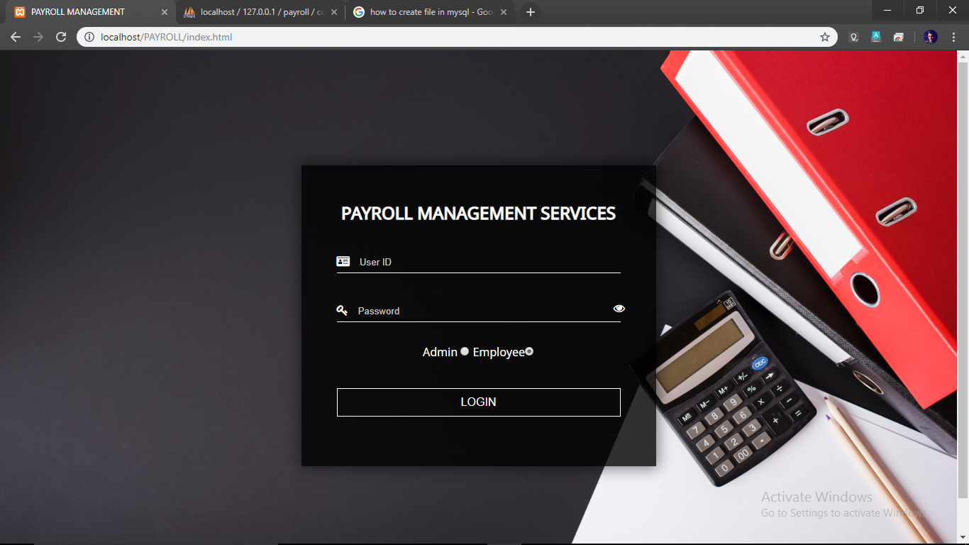

**ADMIN DASHBOARD: -**

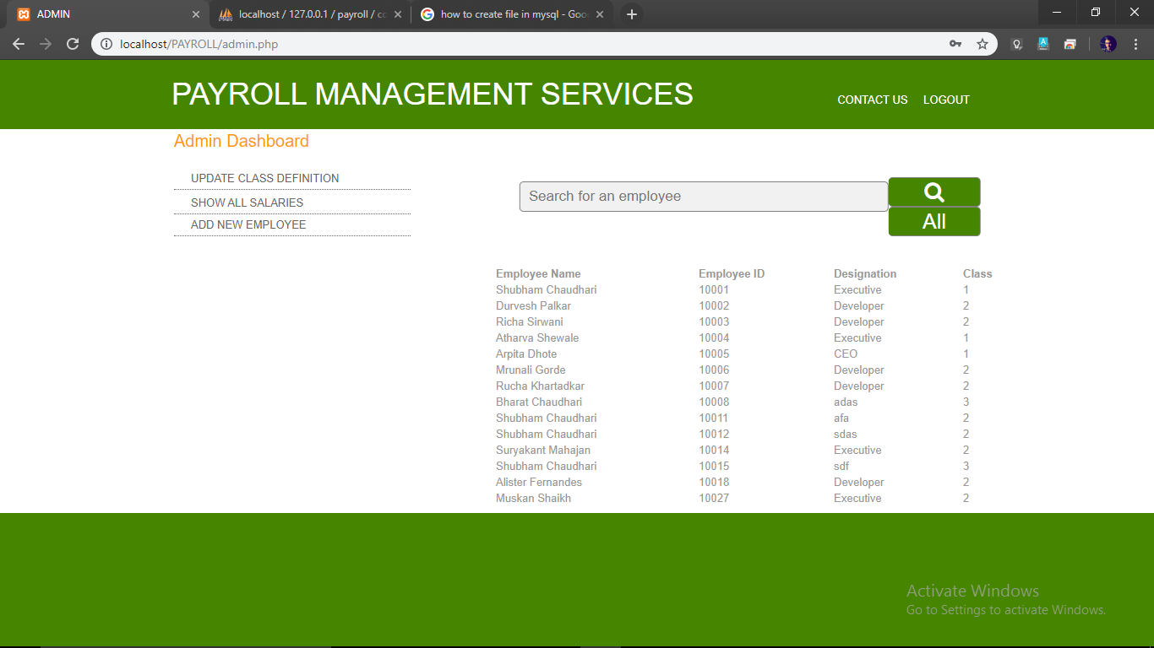

**SEARCH A EMPLOYEE :-**

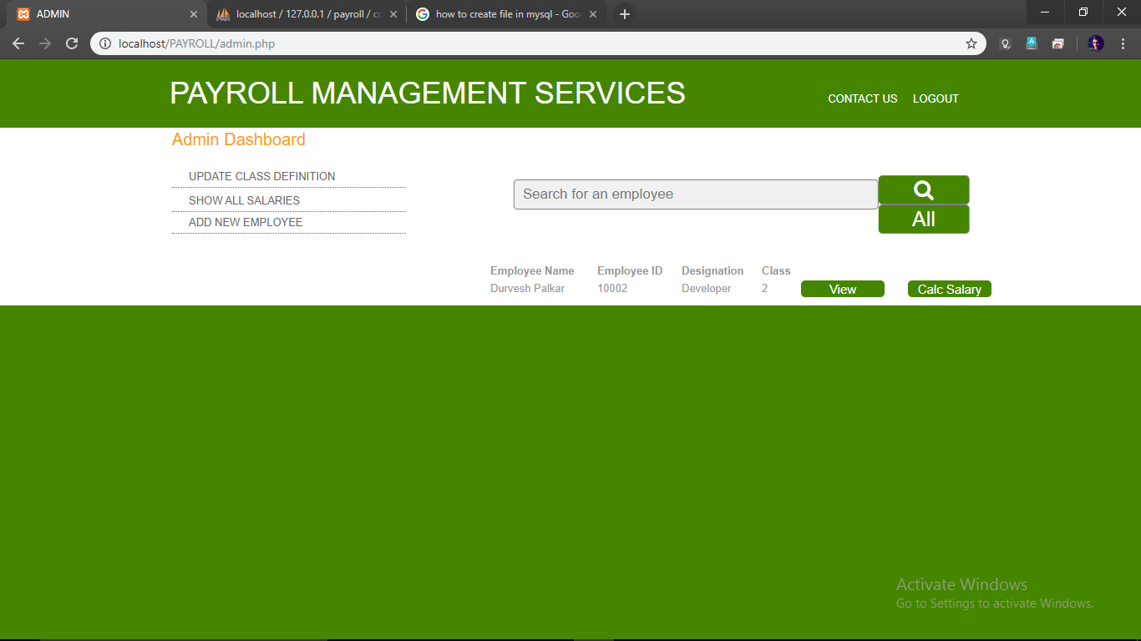

**UPDATE CLASS DEFINATION:-**

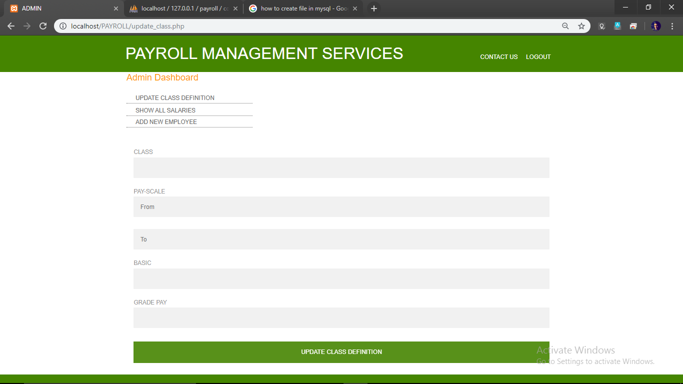

**SHOW ALL SALARIES :-**

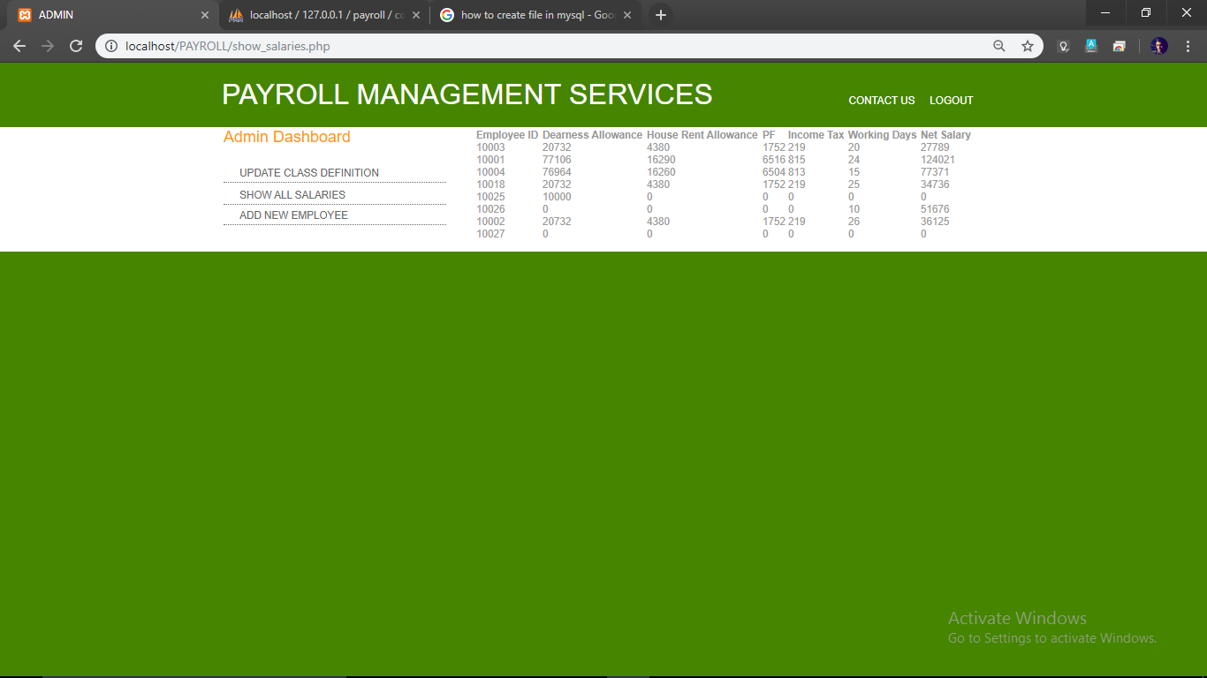

**ADD A NEW EMPLOYEE:-**

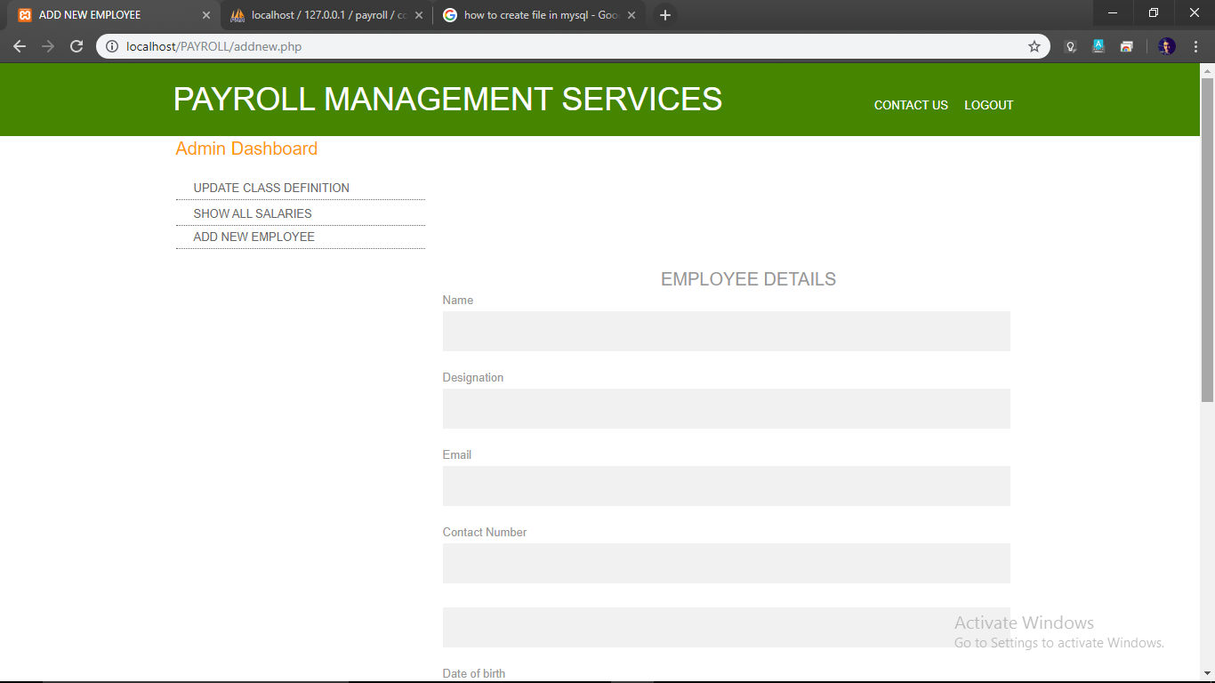

**ENTER NO. OF DAYS :-**

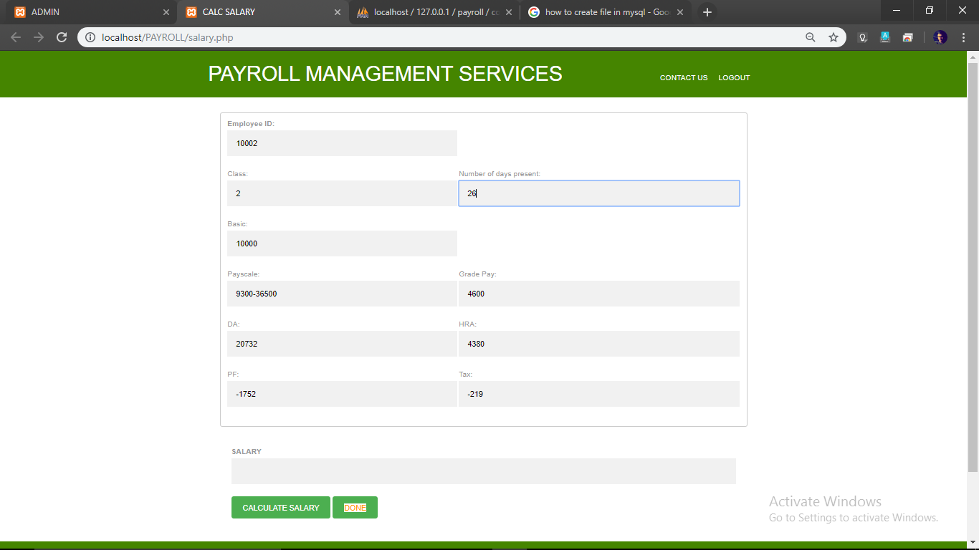

**CALCULATE SALARY :-**

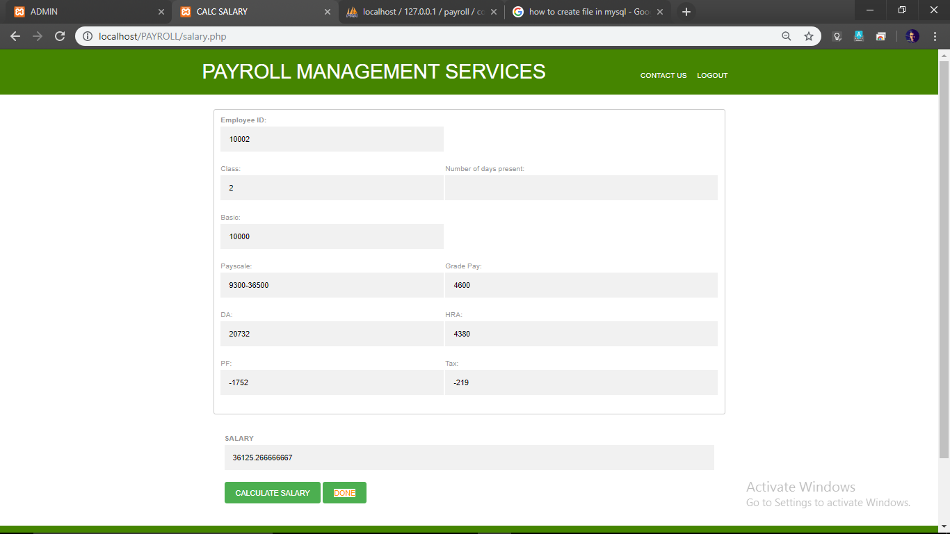

**EMPLOYEE DASHBOARD :-**

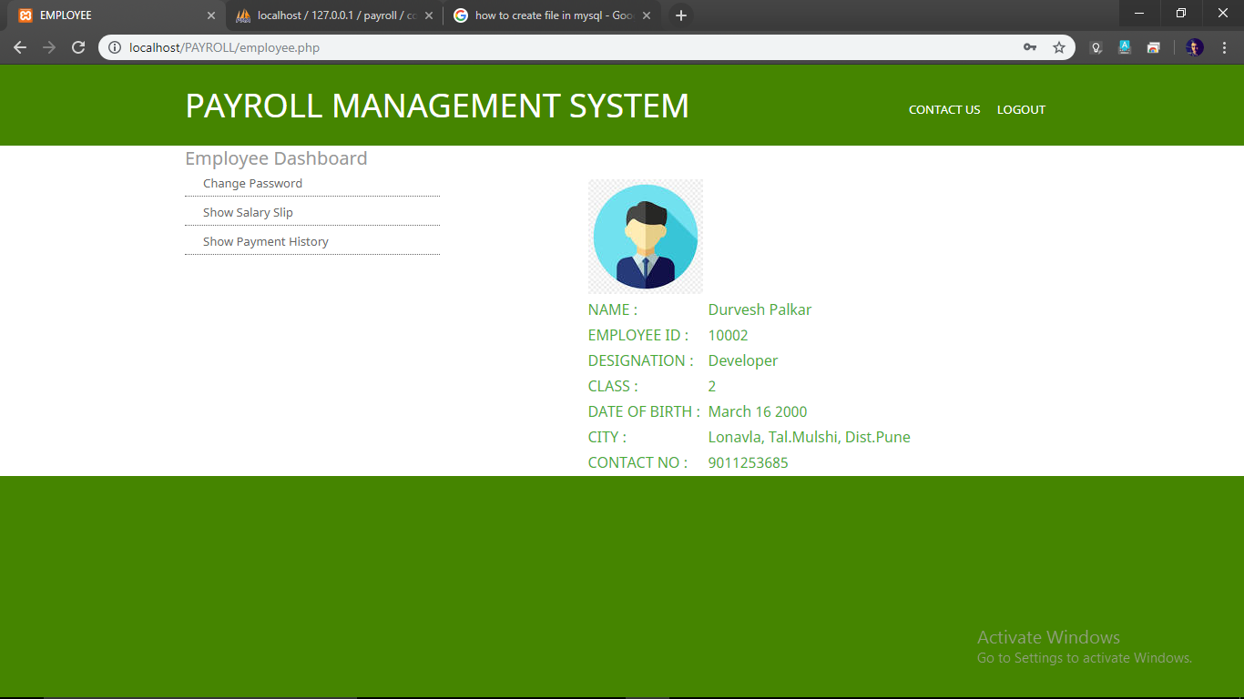

**EMPLOYEE DETAILS :-**

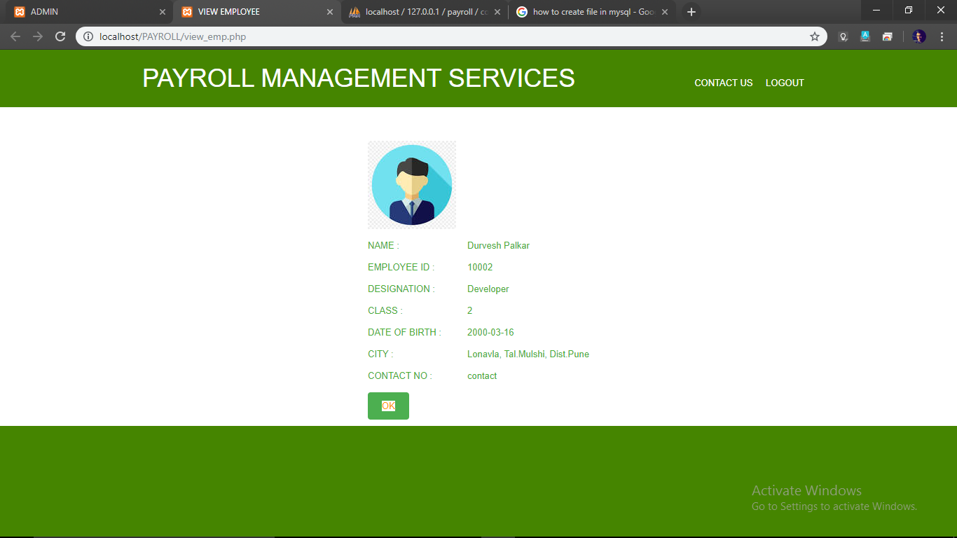

**TO CHANGE PASSWORD :-**

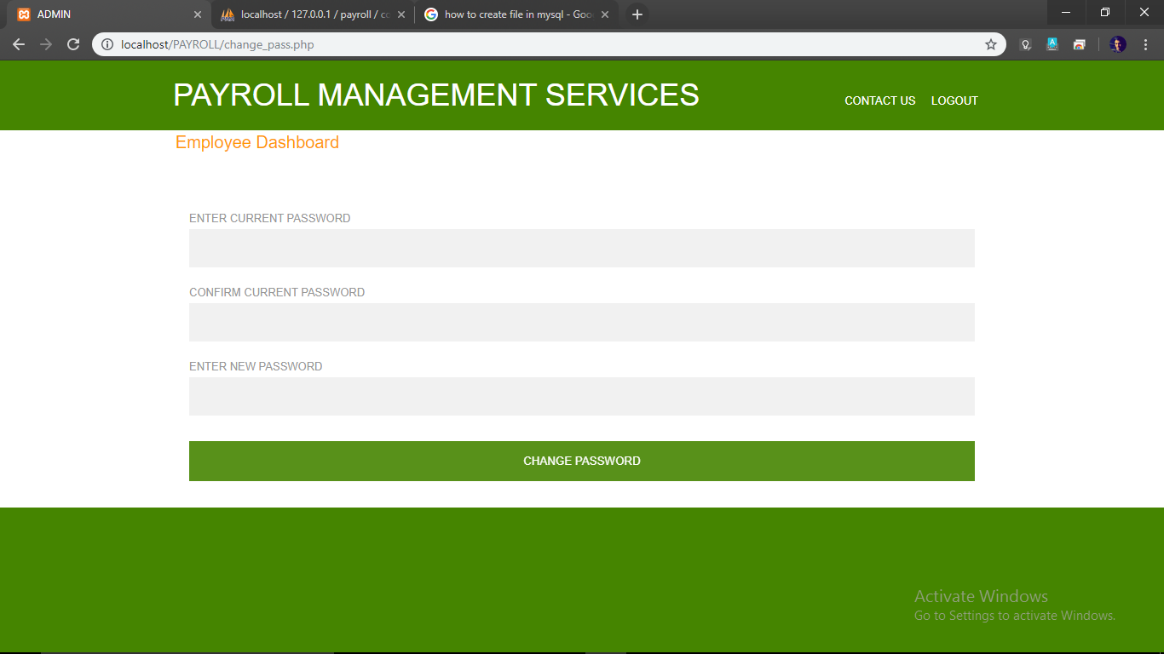

**SALARY SLIP :-**

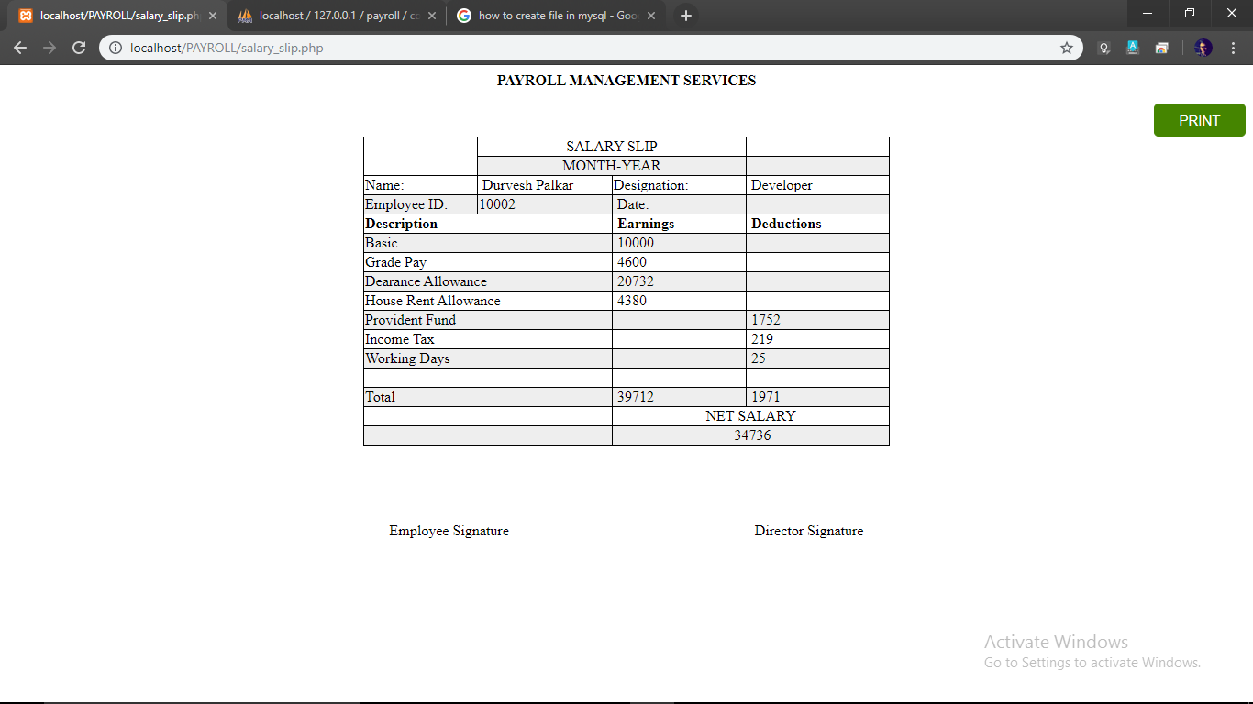

**FUTURE ENHACEMENT**

**Enhance Time Tracking**

Time and attendance data is the basis for [generating payroll](https://www.sutisoft.com/hr-software/payroll-management-software.html). To enhance payroll, integrating attendance information is essential. This is where most businesses usually spend the most time on for traditional payroll. To boost attendance integration, first, consider improving the method of employee time tracking.

If you’re still using manual spreadsheets or punch cards to track employees’ clock in/out, implementing a biometric device may help you reduce costly hours of your HR staff spending on encoding work.

If you’re already using a biometric device but still spend much time exporting data so you can use it for payroll computation. Then implement a robust solution that offers direct integration between your time tracking devices, and your payroll system.

**Automate Shift scheduling**

Implementing an [automated time tracking system](https://www.sutisoft.com/hr-software/time-management-software.html) is usually not enough, especially for businesses with employees whose shifts change from time to time. Without an automated system to manage employee shifts, finding whether an employee is late or early, absent or on leave, will be difficult.

Automating employee shifts not only make matching employees’ logs with their shifts easier, an advanced shift scheduling system help you streamline approvals for attendance-related requests such as time offs, overtime, and shift changes.

**Simplify Payroll Disbursement**

Calculating employees’ salary is not a major challenge for many organizations, but actual payroll disbursement is the critical challenge. Businesses can enhance payroll disbursement by utilizing cash management systems offered by their local banks. These solutions typically allow companies to schedule payroll disbursement and simplify approvals.

Contract a service provider to help in the payroll disbursement process, generally by giving them uploader/maker access to your cash management system – so there is no need to switch to another disbursement method.

This helps you save even more time, so your HR staff has to approve transactions they have already reviewed and approved.

**BENEFITS**

Many businesses choose to use payroll software over manual processing, as it can help them to:

* work out payroll calculations and deductions quicker
* generate accurate payslips
* calculate bonuses, expenses, holiday pay, etc with minimum effort
* remove the need to understand complex tax legislation
* store data such as payslips and annual reports in a secure, easily accessible system

Payroll software can also provide additional data and analysis to make payroll information more useful to your business.

**Linking payroll software with time recording**  
You can link payroll to timesheet systems that record employee attendance or time worked. This allows you to automatically transfer information about hours worked into the payroll system and make payroll calculations much simpler.

**Using payroll software for reporting:**  
With the help of basic payroll data, together with data on attendance and hours worked, payroll systems can provide a wealth of **reports**. This allows in-depth analysis of staff costs for the business as a whole, across departments and even individual jobs and contracts.

**Storing personnel records:**  
Most organisations will also keep other data about employees, such as records of annual leave. By getting payroll systems that record these additional types of information you can avoid the need for a separate software package.

**Using payroll system to plan future costs:**  
As payroll packages can provide forecasts, you can use these to plan staff costs and budgets by entering hypothetical numbers to see the exact total cost of an employee.

**CONCLUSION**

“Payroll Management System” software developed for a company has been designed to achieve maximum efficiency and reduce the time taken to handle the Payroll activity. It is designed to replace an existing manual record system thereby reducing time taken for calculations and for storing data. The system uses HTML5 and CSS as front end and Microsoft SQL as a backend for the database. The system is strong enough to withstand regressive daily operations under conditions where the database is maintained and cleared over a certain time of span. The implementation of the system in the organization will considerably reduce data entry, time and also provide readily calculated reports.

**REFERENCES**

1. [**https://www.w3schools.com/**](https://www.w3schools.com/)
2. [**https://www.tutorialspoint.com/**](https://www.tutorialspoint.com/)
3. [**https://www.youtube.com/**](https://www.youtube.com/)